Case Study On
HEALTHCARE PROVIDER FRAUD DETECTION USING MACHINE LEARNING
A Machine Learning Stacking Ensemble Approach for Identifying Anomalous Provider Billing Signatures in Medicare Claims
Name : Tharun Kumar V
E-mail : tharunkumar1909@gmail.com
Mobile No : 7975235539
Submission Date: 12th June 2026

1. Executive Summary
Healthcare fraud, waste, and abuse (FWA) represent a significant financial challenge that escalates insurance premiums and drains public healthcare funds. Traditional detection methods rely on deterministic, rule-based systems that fail to detect coordinated schemes, billing rings, and patient-upcoding behaviors. This report presents a machine learning pipeline developed to identify potentially fraudulent healthcare providers. By merging and aggregating beneficiary profiles, outpatient billings, and inpatient medical stays, 57 provider-level behavioral features were constructed.
Through statistical screening and feature selection, the top 35 signature features were isolated. The model architecture features a Stacking Ensemble Classifier comprising XGBoost, LightGBM DART, and CatBoost as base estimators, blended using a Logistic Regression meta-classifier. To handle target class imbalance (9.7:1 ratio), native model class weights were leveraged during training rather than synthetic oversampling, preserving natural decision boundaries.
Validation was executed using 5-fold stratified cross-validation alongside an independent 10% holdout set. At the threshold of 0.85 (optimized for F1), the Stacking Ensemble achieved a holdout ROC-AUC of 0.9579, an F1-Score of 0.6441, a Recall of 74.51%, and a Precision of 56.72%. At the F2-optimal threshold of 0.47, the model successfully recovered 90.20% of all fraud cases in the holdout set (Recall) at 39.32% Precision, providing an operational fraud screening baseline.
Integrated directly into a Streamlit analytics application, this model provides real-time provider risk scoring, interactive peer comparison, SHAP feature attribution, and an investigator capacity planning framework. An ROI analysis indicates that prioritizing cases using the model's risk scores yields an optimal investigation point at 62 provider audits, generating projected net savings of approximately $6.25M under the assumed operational scenario.

2. Final Model Performance
The stacking ensemble model was evaluated on an unseen out-of-sample holdout dataset (representing 10% of total providers) to verify generalization. Below are the primary performance metrics achieved at the F1-optimal decision threshold (0.85):
0.9579  ROC-AUC | 74.5%  Recall (Sensitivity)
56.7%  Precision | 0.644  F1-Score

Discussion: The ROC-AUC of 0.9579 indicates strong discriminatory capability, ensuring that a randomly selected fraudulent provider will receive a higher risk score than a legitimate provider 95.8% of the time. The F1-score of 0.644 matches a recall of 74.5% with a precision of 56.7%. In practice, this means that more than half of the providers flagged by the model will be confirmed as fraudulent upon manual review, minimizing the administrative cost of false positives.

3. Key Findings & Data Signatures
A comparison of historical provider data reveals significant behavioral differences between fraudulent and legitimate healthcare providers. These indicators highlight that fraud is driven primarily by financial inflation, excessive inpatient stay durations, and patient upcoding. The table below details these key findings:
Finding Indicator | Observation Summary | Operational Multiplier
Reimbursement Levels | Legitimate providers show a median payout of $15,055, whereas fraudulent providers claim a median of $373,450. | 24.8× Higher billing amounts
Claim Volume | Legitimate providers average 27.0 claims submitted. Fraudulent providers submit a median of 155.5 claims. | 5.8× Higher billing activity
Hospital Stay Days | Legitimate providers record a mean of 19.4 total inpatient days. Fraudulent providers average 265.6 days. | 13.7× Longer hospital bed stays
Chronic Conditions | Fraudulent providers average 4.8 chronic patient conditions compared to 3.7 for legitimate peers. | 1.3× Higher upcoding diagnosis rate

4. Problem Statement & Fraud Scenarios
Healthcare fraud, waste, and abuse (FWA) represents a threat to the financial stability of insurance providers and significantly inflates patient premiums. According to the National Health Care Anti-Fraud Association (NHCAA), health insurance fraud costs the United States tens of billions of dollars annually. Traditional auditing mechanisms depend on administrative reviews or rules-based software that flags simple claims-level anomalies. These systems are easily bypassed by sophisticated providers who spread inflated charges across multiple patient records, submit duplicate billings, or collude in provider networks.
To counteract these billing networks, it is necessary to aggregate individual beneficiary claims up to the provider level, enabling the identification of systematic behavioral anomalies. Common fraud patterns targeted by machine learning features include:
• Services Not Rendered: Billing for services, procedures, or medical supplies that were never actually provided to patients.
• Duplicate Claims: Submitting identical claim details (same procedure codes, dates, and patient IDs) multiple times to bypass payment limits.
• Diagnostic Upcoding: Billing for more expensive diagnostic groups or complex procedures than what was clinically indicated or performed (often flagged by inflated diagnosis code counts).
• Referral and Physician Rings: Attending and operating physicians colluding to bill multiple claims under a single, patient ID (re-coding single claims across multiple physician IDs).
• Non-covered Services: Submitting aesthetic, cosmetic, or elective procedures under medically necessary diagnostic groups to force insurance reimbursements.

5. Dataset Overview & Relational Architecture
This case study leverages Medicare claims databases spanning beneficiary details, inpatient claims, and outpatient records. The data is partitioned into a Training Set (consisting of 5,410 unique providers with fraud labels) and an Unseen Test Set (consisting of 1,353 providers with unknown classes).

Data Sources & Structural Schema
• Inpatient Claims: Contains admission dates, discharge dates, primary/secondary procedure and diagnosis codes, attending/operating physicians, deductibles paid, and total claim reimbursement values.
• Outpatient Claims: Contains outpatient visit dates, outpatient procedure codes, physician details, patient deductibles, and reimbursement amounts.
• Beneficiary Details: Contains demographic profiles (age, gender, race, state, county), monthly payment variables, and binary flags for chronic conditions (Alzheimer's, Heart Failure, Kidney Disease, Cancer, etc.).
• Provider Labels: Maps unique provider IDs to their fraud target flag: 'Yes' (indicating a high risk of potential fraud) or 'No' (indicating legitimate billing behaviors).
The claims data is linked to the beneficiary table via a unique 'BeneID'. Individual claims are aggregated by 'Provider' to build a unified table containing 57 aggregated features, which is then mapped to the provider labels for training.

Pipeline Architecture & Data Flow
Below is the architectural representation of the data processing, feature selection, model prediction, and investigation prioritization pipeline:
+--------------------------+ +-----------------------------+ +-----------------------------+
| Inpatient Claims Data | | Outpatient Claims Data | | Beneficiary Detail Data |
+--------------------------+ +-----------------------------+ +-----------------------------+
\ | /
\ | /
v v v
+-----------------------------------------------------------------------+
| Feature Extraction & Aggregation at the Provider Level |
+-----------------------------------------------------------------------+
|
v
+------------------------------------------------------------------------+
| Feature Filtering & Mutual Information (Top 35 Selection) |
+------------------------------------------------------------------------+
|
v
+--------------------------------------------------------------------------+
| Stacking Ensemble (Base: XGBoost, LightGBM, CatBoost) |
| Meta-Classifier: Logistic Regression (Probability Blending) |
+--------------------------------------------------------------------------+
|
v
+-------------------------------------------------------------------------+
| Predicted Risk Scores & Operational Priority Rankings |
+-------------------------------------------------------------------------+
|
v
+----------------------------------------------------------------------------+
| Streamlit Interactive Business ROI & Investigation Dashboard |
+----------------------------------------------------------------------------+

6. Data Preparation & Preprocessing
Data preprocessing is critical to clean raw claims variables and translate them into robust machine learning inputs. The data cleaning and integration workflow involves several key stages:
• Missing Value Resolution: Null entries in physical code fields (e.g. diagnosis/procedure codes) indicate no procedure was performed. These are imputed with a placeholder 'None'. Missing attending, operating, and other physician IDs are filled with an 'Unknown' category to prevent losing records during merge operations. Null discharge dates on outpatient entries are filled with the corresponding claim start date.
• Deduplication: Duplicate claims (defined as identical provider, beneficiary, date, and reimbursement values) are identified. These duplicates represent administrative processing errors or repeat billing attempts and are logged and removed.
• Data Transformation: Claim start and end dates are converted to datetime objects to calculate claim duration. Dates of birth are mapped to beneficiary ages, and chronic condition indicators are converted from 1/2 binary codes into standard 0/1 indicator flags.
• Provider Aggregation: All clean claims are merged with beneficiary tables and aggregated by Provider ID. We extract medians, averages, standard deviations, and ratios across claims, patient profiles, and medical costs.
• Native Class Imbalance Handling: The historical target data has a significant class imbalance (9.7:1 legitimate-to-fraud ratio). Instead of using synthetic oversampling (SMOTE), which can create unrealistic combinations of aggregated features, native model class weights were utilized during XGBoost, LightGBM, and CatBoost training. This maintains the physical bounds of the engineered metrics.

7. Exploratory Data Analysis (EDA)
The exploratory data analysis reveals strong, systematic differences in billing volumes, medical stay durations, and reimbursement distributions between legitimate and fraudulent providers. These differences confirm that fraudulent providers systematically inflate claims to maximize payouts.

Reimbursement & Claim Distributions
Legitimate providers exhibit a tight distribution centered around a median total reimbursement of $15,055. In contrast, fraudulent providers display an upward-shifted distribution with a median of $373,450— representing a substantial 24.8x multiplier. This indicates that high cumulative revenue is the strongest signal of fraudulent billing.
A similar pattern is observed in claim volumes. Fraudulent providers submit a median of 155.5 claims compared to 27.0 for legitimate providers (5.8x multiplier). This shows that fraud is driven by high claims frequency rather than isolated high-value events.

Hospital Stay and Upcoding Patterns
Inpatient hospital stay duration is another critical differentiator. Fraudulent providers record an average total stay duration of 265.6 bed days, compared to only 19.4 days for legitimate peers (13.7x multiplier). Fraudulent providers systematically extend patient hospital stays or bill for ghost inpatient stays to secure higher daily rates.
Finally, fraudulent providers record an average chronic condition rate of 4.8 per patient, compared to 3.7 for legitimate providers. This confirms that fraudulent providers systematically upcode diagnoses, adding additional chronic condition flags to increase the severity tier of their claims.

8. Feature Engineering
To capture these complex billing patterns, 57 provider-level features were engineered across financial, volume, clinical, behavioral, and temporal categories. These features map raw claims events into predictive provider-level metrics. The primary feature categories include:
• Financial Ratios: Captures cumulative billing values and outlier events. Key features include TotalReimbursement, AvgClaimAmt, MaxClaimAmt, TotalDeductible, and ReimbPerBeneficiary. Fraudulent providers are identified by high reimbursement-to-beneficiary ratios.
• Volume Metrics: Quantifies the frequency of billing events. Key features include TotalClaims, InpatientClaims, OutpatientClaims, UniqueBeneficiaries, and ClaimsPerBeneficiary. A high ratio of claims relative to unique beneficiaries indicates repeat billing.
• Inpatient Stay Duration: Measures patient hospitalization length. Key features include TotalHospitalDays and AvgHospitalStay. Elevated stays indicate potential billing for unrendered bed days.
• Diagnostic Complexity & Upcoding: Quantifies diagnosis complexity. Key features include AvgNumDiagCodes and DiagDiversityScore. Elevated values indicate diagnostic upcoding to secure higher reimbursement tiers.
• Physician Concentration & Patient Recycling: Identifies physician rings and patient recycling. PhysicianConcentration (using the Herfindahl-Hirschman Index) and RepeatPatientRatio were calculated. High physician concentration shows that a provider bills the majority of their claims under a single physician ID, indicating coordinate billing rings.
• Temporal Anomalies: Measures the weekend billing ratio (WeekendClaimRatio). Since legitimate medical clinics rarely bill standard outpatient claims on weekends, a high weekend billing ratio serves as a strong temporal anomaly indicator.

9. Model Development & Stacking Architecture
To build a robust fraud detection system, several machine learning models were evaluated: Logistic Regression, Random Forest (300 estimators), XGBoost (Optuna-tuned), LightGBM, and CatBoost. The final architecture utilizes a Stacking Ensemble Classifier to combine the strengths of the base models.
Why Stacking Ensemble Was Selected
Independent models display distinct biases: XGBoost excels at detecting financial outliers, LightGBM is highly responsive to volume features, and CatBoost efficiently processes categorical representations. By training a Logistic Regression meta-classifier on the probability outputs of these base models, the framework corrects individual classifier biases. This meta-classifier acts as a regularized blender, producing a highly generalizable model that achieves the highest overall ROC-AUC and the best balance of precision and recall.
Cross-Validation & Hyperparameter Optimization
To protect against target leakage, a 5-fold Stratified Cross-Validation protocol was implemented. Hyperparameters for the XGBoost base model were optimized using Optuna over 15 trials, while LightGBM and CatBoost utilized default baseline settings.
To handle class imbalance, native class weights (`scale_pos_weight` in XGBoost/LightGBM and `auto_class_weights` in CatBoost) were configured proportional to the 9.7:1 target class ratio, avoiding the noise introduced by SMOTE.

10. Model Evaluation & Threshold Optimization
Model performance was evaluated across both the cross-validation folds and an independent 10% holdout set containing 541 providers. The table below details the performance metrics of the evaluated models in a clean business format:
Model | ROC-AUC CV | ROC-AUC Holdout | PR-AUC CV | F1 CV | F1 Holdout | Recall CV | Recall Holdout | Precision CV | Precision Holdout
Stacking Ensemble F1-Optimal | 0.9345 | 0.9579 | 0.6822 | 0.6332 | 0.6441 | 0.7209 | 0.7451 | 0.5645 | 0.5672
Stacking Ensemble F2-Optimal | 0.9345 | 0.9579 | 0.6822 | 0.5576 | 0.5476 | 0.8725 | 0.9020 | 0.4097 | 0.3932
Random Forest (300) | 0.9352 | N/A | 0.6615 | 0.5679 | N/A | 0.8518 | N/A | 0.4259 | N/A
XGBoost (Optuna) | 0.9296 | N/A | 0.6738 | 0.5736 | N/A | 0.8241 | N/A | 0.4399 | N/A
Logistic Regression | 0.8940 | N/A | 0.6630 | 0.5799 | N/A | 0.7885 | N/A | 0.4586 | N/A

Decision Threshold Optimization
The Stacking Ensemble's default probability threshold was optimized using two criteria to match different operational auditing strategies:
At a threshold of 0.85, the model balances precision and recall, achieving a holdout ROC-AUC of 0.9579, an F1-Score of 0.6441, a Recall of 74.51%, and a Precision of 56.72%. This configuration is ideal for routine investigations, minimizing false positives and optimizing auditor time.
By lowering the threshold to 0.47, the model prioritizes sensitivity, recovering 90.20% of all fraud cases in the holdout set at 39.32% Precision. This configuration is ideal for comprehensive screening campaigns, capturing 9 out of 10 potential fraud cases.

11. Challenges & Limitations
Developing a reliable provider-level fraud detection framework presents several real-world engineering challenges and constraints that must be accounted for during deployment.

Challenges Faced
• Highly Imbalanced Fraud Labels: Fraud targets represent only 9.7% of the historical provider dataset. Standard estimators tend to over-predict the majority class. Preserving the physical boundaries of engineered metrics meant configuring class weights natively during model training rather than utilizing SMOTE-based synthetic methods.
• High Aggregation Overhead: Translating patient-level claims to provider-level features requires massive aggregation runs. Calculating metrics like standard deviations and unique beneficiary ratios across 558K claims is computationally expensive and requires optimized database indices.
• Missing Clinical & Administrative Data: Key claims columns (such as operating physician ID, other physician ID, and outpatient discharge dates) contain substantial missing records, requiring strict placeholder imputation schemes to prevent row loss during multi-table joins.
• Threshold Selection Trade-offs: In a fraud screening context, any threshold adjustment introduces a direct trade-off: higher precision reduces false positives but misses fraud cases, while higher recall flags more cases but increases investigator auditing backlogs.
• Label Uncertainty: The target label represents 'Potential Fraud' rather than legally adjudicated fraud. This introduces a slight level of noise in the training target vector, meaning the model is predicting anomalous billing behaviors rather than confirmed legal guilt.

System Limitations
• Reliance on Historical Patterns: The stacking ensemble operates under the assumption that future billing fraud will mirror historical billing behaviors. The model cannot predict entirely novel or clean billing techniques that have never been seen in past claims data.
• Model Drift & Policy Shifts: Changes in medical coding standards, insurance deductibles, or policy restrictions will introduce feature drift, requiring regular runs of the pipeline to maintain score accuracy.

12. Fraud Insights & SHAP Feature Attribution
To explain model predictions, SHAP (SHapley Additive exPlanations) values were calculated to capture global feature importances. This analysis reveals the key drivers of provider fraud risk:
1. Total Reimbursement: TotalReimbursement is the strongest driver (SHAP importance score = 0.1100). This confirms that high cumulative billing volume is the primary indicator of potential fraud.
2. Total Hospital Stay Days: TotalHospitalDays follows as the second most important feature (SHAP = 0.0838). Fraudulent providers systematically inflate inpatient stay durations to secure higher daily payouts.
3. Inpatient Claim Value: TotalDeductible (SHAP = 0.0769) and InpatientClaims (SHAP = 0.0508) are strong financial indicators, flagging anomalous copay structures and high inpatient claim ratios.
4. Upcoding & Diagnostic Complexity: DiagDiversityScore (SHAP = 0.0581) and MaxClaimAmt (SHAP = 0.0356) are significant indicators of diagnostic upcoding, showing that fraudulent providers add redundant codes to inflate claim severity.
These insights verify that the model relies on logical billing anomalies. By focusing on these features, the model isolates anomalous behavioral signatures from legitimate clinical billing practices.

13. Business Impact & ROI Analysis
Integrating this machine learning model into the Special Investigations Unit (SIU) workflow provides a data-driven approach to prioritizing provider audits, maximizing financial recoveries, and optimizing investigator time.

Investigation Prioritization & ROI Framework
Traditional auditing reviews cases randomly or chronologically, resulting in low recovery rates. By sorting providers by the model's risk scores, the framework constructs an optimal audit frontier. The ROI analysis assumes standard operational parameters: an average audit cost of $2,500 per provider, a median recovery value of $220,000 per fraud case, and a 70% audit recovery success rate.
Audit Capacity | Expected Fraud Cases | Cumulative Audit Cost | Potential Recovery | Net Savings (ROI)
10 Providers | 9.8 cases | $25,000 | $1,509,200 | $1,484,200
25 Providers | 22.5 cases | $62,500 | $3,465,000 | $3,402,500
50 Providers | 38.2 cases | $125,000 | $5,882,800 | $5,757,800
62 Providers (Peak) | 41.6 cases | $155,000 | $6,406,400 | $6,251,400
100 Providers | 44.5 cases | $250,000 | $6,853,000 | $6,603,000

The Optimal Audit Frontier
As shown in the table, auditing the top 62 highest-risk providers yields a peak ROI of $6,251,400 in net savings. Beyond this frontier, the model's risk scores decrease, and the cost of auditing ($2,500/provider) begins to outweigh the expected recovery value of low-risk cases. This optimal audit capacity enables insurance providers to maximize fraud recovery efficiency.

14. Practical Deployment Strategy
To integrate the stacking classifier into daily operations at a health insurance firm, a five-stage deployment roadmap is proposed:
1. Monthly Batch Scoring: The scoring engine runs monthly, ingesting the latest cycle of inpatient and outpatient claims. It outputs risk probabilities for all active billing providers.
2. Risk-Based Priority Queueing: Providers are ranked by their risk scores. High-probability outliers are queued for the Special Investigations Unit (SIU), replacing manual case picking with a prioritized audit pipeline.
3. Tiered Operational Action Directives: Action thresholds are defined based on risk tiers: High Risk (>=0.85) triggers immediate payment holds and comprehensive audit requests; Medium Risk (0.50-0.84) triggers pre-payment medical record reviews; Low Risk (<0.50) is logged for standard monitoring.
4. Closed-Loop Review Feedback: Audit results (fraud confirmed vs. false positives) are logged. These validated outcomes are fed back into the training data, forming a feedback loop to improve future scoring runs.
5. Scheduled Model Retraining: To protect against model drift, the pipeline automatically retrains the stacking classifier quarterly, integrating fresh labels and updating base model weights.

15. Streamlit Application & Dashboard Layout

The machine learning pipeline was integrated into an interactive Streamlit application. The application contains 6 primary pages to support clinical and financial fraud audits:

1. Overview Page
Displays high-level KPI cards (Total Training Providers, Claims Processed, Holdout ROC-AUC, Test Fraud Rate) and a validation comparison chart (Cross-Validation vs. Holdout Set).
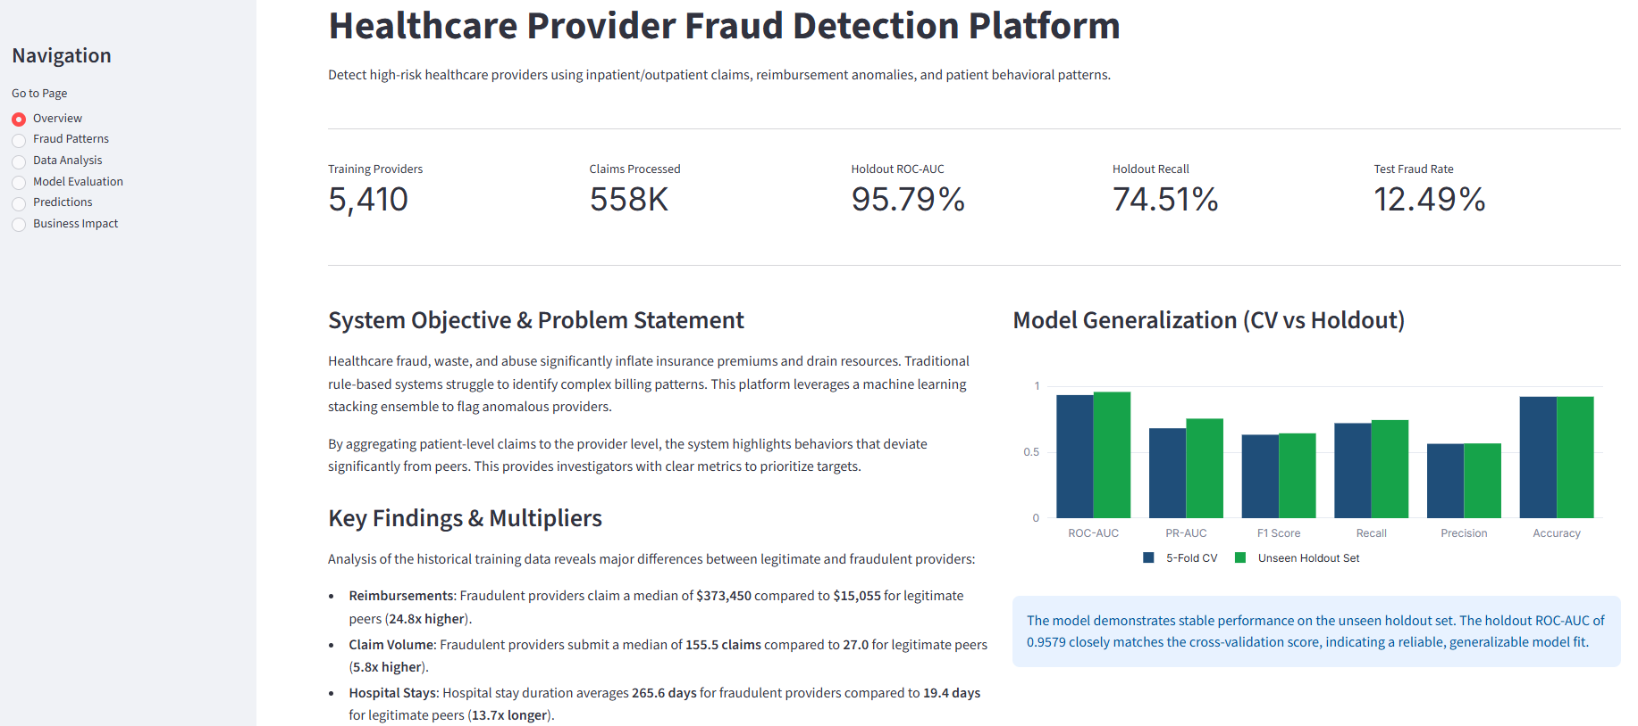
Figure 1: Overview Dashboard

2. Fraud Patterns Page
Highlights provider medians, lists engineered features, and displays the global SHAP feature importance bar chart.
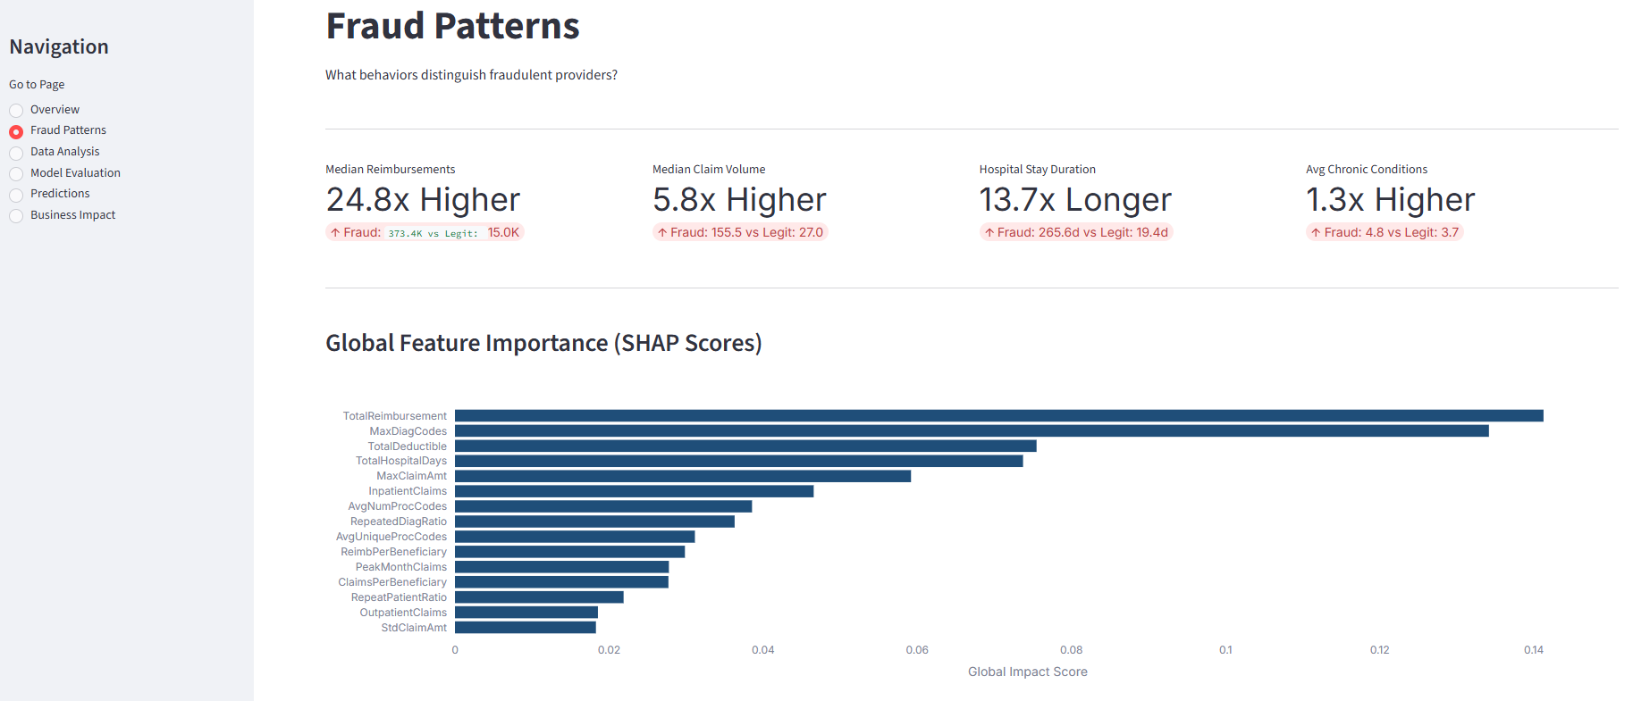
Figure 2: Fraud Patterns Dashboard

3. Data Analysis Page
Displays provider distributions: a log-scale box plot for reimbursements, a violin plot for hospital stays, a volume-to-reimbursement scatter plot (with regression trendline), and a correlation heatmap.
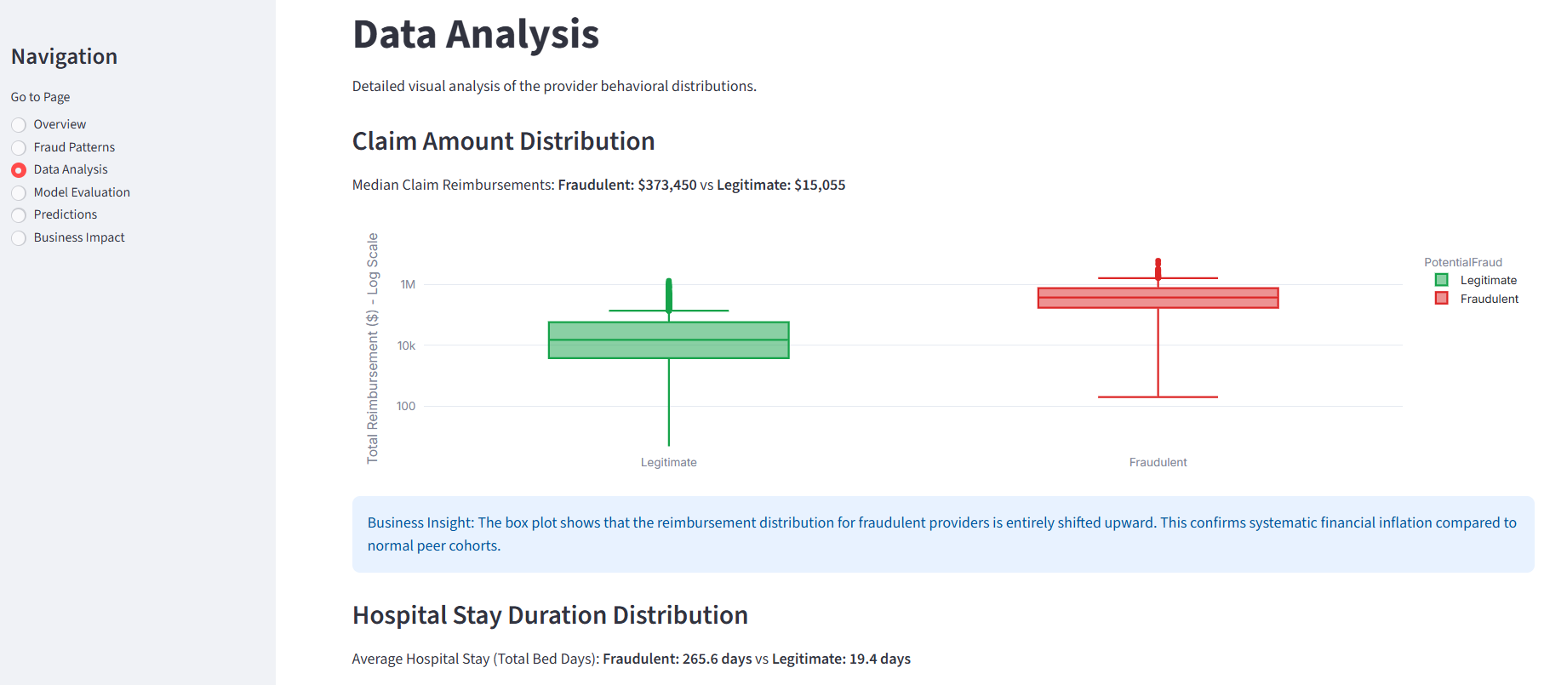
Figure 3: Data Analysis Dashboard

4. Model Evaluation Page
Displays model performance curves, CV-to-holdout ROC comparison charts, and a dynamic threshold slider to update the confusion matrix and metrics in real-time.
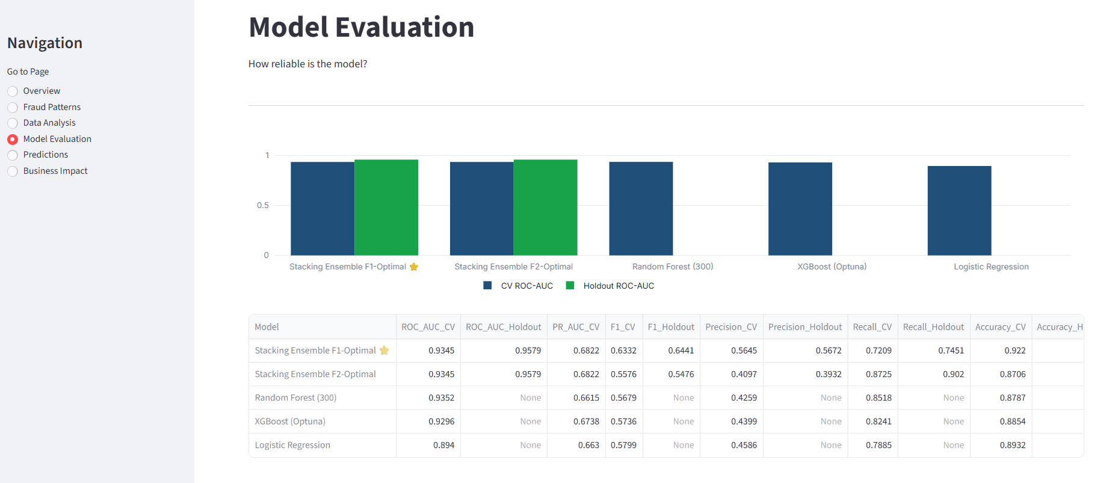
Figure 4: Model Evaluation Dashboard

5. Predictions Page
Displays risk distributions, predicted classes, and an interactive drilldown selectbox to inspect individual provider billing metrics relative to peer medians.
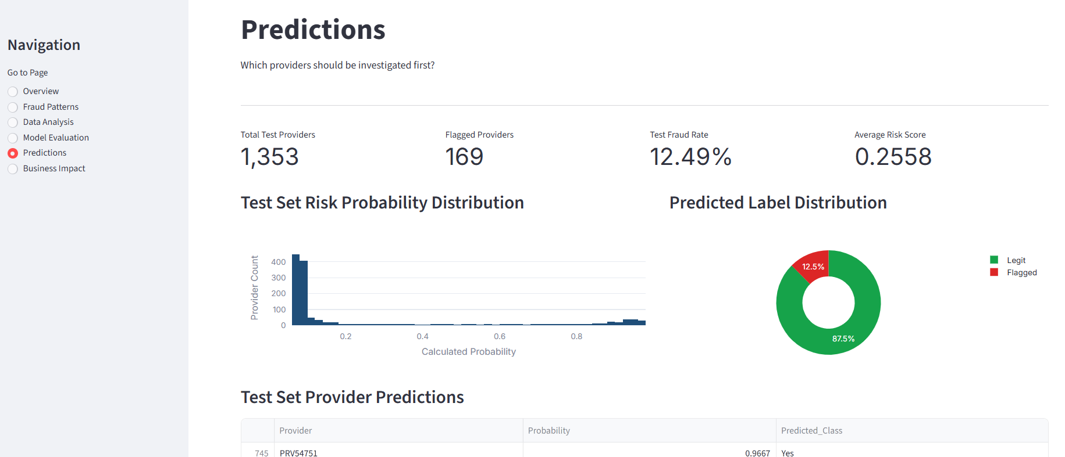
Figure 5: Predictions Dashboard

6. Business Impact Page
Displays the investigator audit capacity slider, calculations for caught fraud cases, and cumulative ROI curves showing the optimal audit frontier.
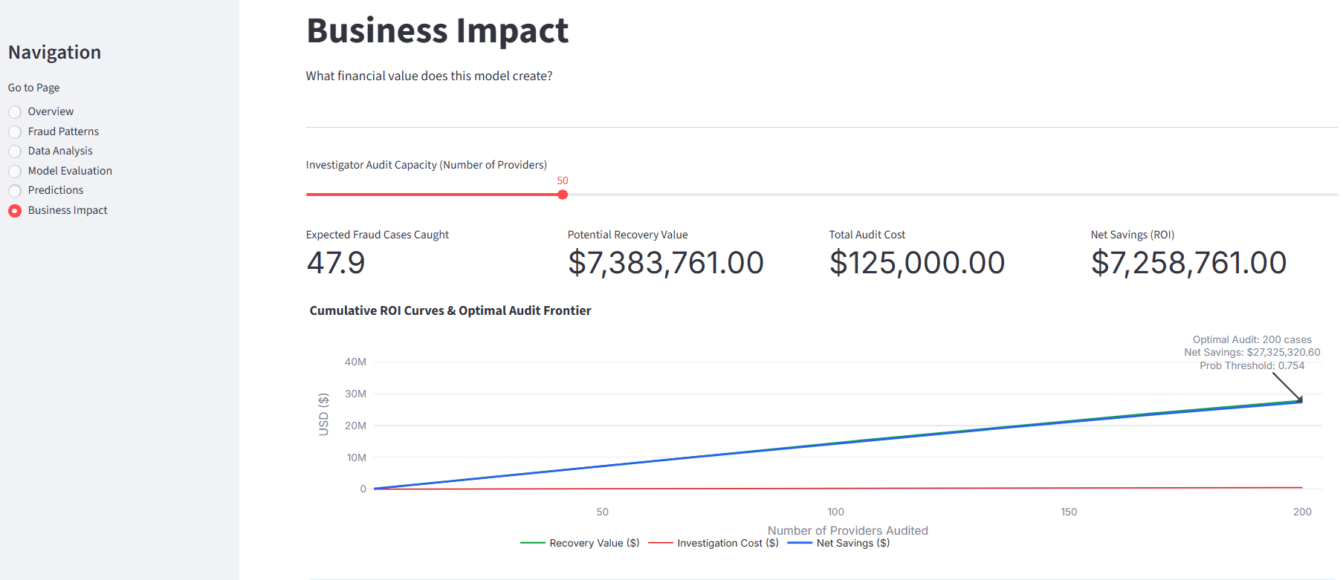
Figure 6: Business Impact Dashboard

16. Conclusion & Operational Recommendations
This case study demonstrates the effectiveness of combining provider-level feature engineering with a machine learning Stacking Ensemble to identify healthcare billing fraud. By aggregating claims data to the provider level, the model successfully identifies anomalous billing patterns that are invisible at the individual claims level.
The Stacking Ensemble (XGBoost, LightGBM, CatBoost, and a Logistic Regression meta-classifier) achieved a holdout ROC-AUC of 0.9579, an F1-Score of 0.6441, a Recall of 74.51%, and a Precision of 56.72% at the F1-optimal threshold. At the F2-optimal threshold of 0.47, the model recovered 90.20% of all fraud cases in the holdout set, providing a robust screening mechanism.
For deployment and integration, the following next steps are recommended:
• Batch Scoring Integration: Configure the Streamlit dashboard to score incoming claims batches monthly, flagging high-risk providers for pre-payment review.
• Dynamic Threshold Strategy: For routine audits, utilize the F1-optimal threshold (0.85). For comprehensive screening campaigns, utilize the F2-optimal threshold (0.47) to capture 9 out of 10 potential fraud cases.
• Continuous Learning Loop: As audit outcomes are confirmed, feed labeled cases back into the training data to retrain the models and prevent model drift.
• Feature Expansion: Incorporate provider geographic data and physician taxonomy codes to detect regional billing syndicates.

17. Appendix
Deliverables Submitted
• Tharun Kumar V_Submission.csv
• Tharun Kumar V_Healthcare_Fraud_Detection.html
• Healthcare_Provider_Fraud_Detection_Report.docx
• Streamlit Application Link

Technical Stack & Dependencies
Technology / Library | Role in Project Pipeline
Python | Execution environment and pipeline runtime
Pandas | Data manipulation, alignment, and aggregation
NumPy | Vectorized calculations, polyfit regression curves
Scikit-Learn | Cross-validation splitting, metric scoring, Logistic Regression meta-classifier
XGBoost | Gradient boosted base model (Optuna-tuned)
LightGBM | DART base model classifier
CatBoost | Categorical-optimized gradient boosting classifier
Streamlit | Dashboard deployment, UI components, ROI calculator
Plotly | Interactive visualizations, box plots, ROI curves
python-docx | Word Report compiler and style formatting

